create different tables:

Creating table sailors
CREATE TABLE sailors
(
sid integer,
snamevarchar(20),
rating integer,
age integer
);

Creating table boats
CREATE TABLE boats
(
bid integer,
bnamevarchar(20),
colorvarchar(20)
);

Creating table reserves
CREATE TABLE reserves
(
sid integer,
bid integer,
day1 date
);

After creating all the tables, we have to insert records into these tables:
Insert records into the sailorstable:
insert into sailors values(22,'dustin',7,45);
insert into sailors values(29,'brutus',1,33);
insert into sailors values(31,'lubber',79,55);
insert into sailors values(32,'andy',8,25);
insert into sailors values(58,'rusty',10,35);
insert into sailors values(58,'buplb',10,35);
insert into sailors values(58,'buplerb',10,35);
insert into sailors values(22,'bb',10,35);

Insert records into the boats table:
insert into boats values(101,'interlake','blue');
insert into boats values(102,'interlake','red');
insert into boats values(103,'clipper','green');
insert into boats values(104,'marine','red');

Insert records into the reserves table:
insert into reserves values(22,101,'2004-01-01');
insert into reserves values(22,102,'2004-01-01');
insert into reserves values(22,103,'2004-02-01');
insert into reserves values(22,105,'2004-02-01');
insert into reserves values(31,103,'2005-05-05');
insert into reserves values(32,104,'2005-04-07');

After all creating database, creating tables and then inserting records into them, we have to perform queries on these tables:

Problem#1:
Find the names of sailors who have reserved a red boat.
Solution:
SELECT s.sname
FROM sailors s
JOIN reserves r
ON r.sid=s.sid join boats b
ON r.bid=b.bid where b.color='red';

Problem#2:
Find the names of the Sailors who have reserved at least one boat.
Solution:
SELECT sname
FROM sailors
WHERE sid
IN (
SELECT sid
FROM reserves
GROUP BY sid
);

Problem#3:
Compute increments for the ratings of persons who have sailed two different boats on the same day.
Solution:
SELECT r.sid, r.day1, COUNT(*), s.rating
FROM reserves r
JOIN sailors s
ON r.sid=s.sid
GROUP BY day1
HAVING COUNT(r.day1)=2;

/*Or*/

SELECT s.sid, s.sname, COUNT(r.sid) c, s.rating+1 "rating"
FROM sailors s
JOIN reserves r ON s.sid=r.sid GROUP BY day1
HAVING c>1;

SELECT * FROM sailors;

Problem#4:
Find the ages of sailors whose name begins and ends with B and has at least 3 characters.
Solution:
SELECT sname, age
FROM sailors
WHERE sname LIKE 'B%_%B';

Problem#5:
Find the names of sailors who have reserved a red and a
green boat.
Solution:
SELECT s.sname, b.color, s.sid
FROM sailors s
JOIN reserves r ON r.sid=s.sid
JOIN boats b ON r.bid=b.bid
AND b.color='red'
WHERE r.sidIN(
SELECT s.sid
FROM sailors s
JOIN reserves r ON r.sid=s.sid
JOIN boats b ON r.bid=b.bid
WHERE b.color='green'
);

Problem #6:
Find the sids of all sailors who have reserved red boats but not green boats.
Solution:
SELECT s.sname, b.color, s.sid
FROM sailors s
JOIN reserves r ON r.sid=s.sid
JOIN boats b ON r.bid=b.bid
AND b.color='red'
WHERE r.sid NOT IN(
SELECT s.sid
FROM sailors s
JOIN reserves r ON r.sid=s.sid
JOIN boats b ON r.bid=b.bid
WHERE b.color='green'
);
SELECT s.sname, b.color, s.sid
FROM sailors s
JOIN reserves r ON r.sid=s.sid
JOIN boats b ON r.bid=b.bid
WHERE b.color='green';

Problem#7:
Find the sailors with the highest rating.
Solution:
SELECT sname, max(rating)
FROM sailors;

Problem#8:
Find the name of the oldest sailor.
Solution:
SELECT sname
FROM (
SELECT sname,max(age)
FROM sailors
) t1;

Problem #9:
Count the number of different sailor names.
Solution:
SELECT COUNT(*)
FROM (
SELECT sname
FROM sailors
GROUP BY sname
) t1;

Problem #10:
Find the no. of sailors who is eligible to vote for each
rating level.
Solution:
SELECT COUNT(sname), rating
FROM sailors
WHERE age>18 group by rating;

Creating procedures Inmysql
CREATEPROCEDURE
DELIMITER //
CREATEPROCEDURE cust2()
BEGIN
SELECT*
FROM Customers
WHEREaddress = 'bhopal';
END //
DELIMITER ;

To call procedures
CALL customers1()

To delete procedures

DROPPROCEDUREus_customers;

Joins in DBMS
Create tables
mysql> select * from customer;
+------+--------+
| c_id | c_name |
+------+--------+
| 1 | john |
| 1 | robert |
| 3 | david |
| 4 | john |
| 5 | betty |

select * from orders;
+------+--------+------+
| o_id | amount | c_id |
+------+--------+------+
| 1 | 200 | 10 |
| 2 | 500 | 3 |
| 3 | 300 | 6 |
| 4 | 800 | 5 |
| 5 | 150 | 8 |

SQL Joins (Inner, Left, Right and Full Join)
Last Updated : 17 Dec, 2024

SQL joins are the foundation of database management systems, enabling the combination of data from multiple tables based on relationships between columns. Joins allow efficient data retrieval, which is essential for generating meaningful observations and solving complex business queries.
Understanding SQL join types, such as INNER JOIN, LEFT JOIN, RIGHT JOIN, FULL JOIN, and NATURAL JOIN, is critical for working with relational databases.
In this article, we will cover the different types of SQL joins, including INNER JOIN, LEFT OUTER JOIN, RIGHT JOIN, FULL JOIN, and NATURAL JOIN. Each join type will be explained with examples, syntax, and practical use cases to help us understand when and how to use these joins effectively.

What is SQL Join?
SQL JOIN clause is used to query and access data from multiple tables by establishing logical relationships between them. It can access data from multiple tables simultaneously using common key values shared across different tables. We can use SQL JOIN with multiple tables. It can also be paired with other clauses, the most popular use will be using JOIN with WHERE clause to filter data retrieval.

Example of SQL JOINS
Consider the two tables, Student and StudentCourse, which share a common column ROLL_NO. Using SQL JOINS, we can combine data from these tables based on their relationship, allowing us to retrieve meaningful information like student details along with their enrolled courses.

Student Table

StudentCourse Table
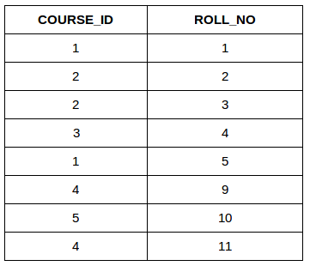
Both these tables are connected by one common key (column) i.e ROLL_NO. We can perform a JOIN operation using the given SQL query:
Query:
SELECT s.roll_no, s.name, s.address, s.phone, s.age, sc.course_id
FROM Student s
JOIN StudentCoursesc ON s.roll_no = sc.roll_no;
Output
ROLL_NO | NAME | ADDRESS | PHONE | AGE | COURSE_ID
1 | HARSH | DELHI | XXXXXXXXXX | 18 | 1
2 | PRATIK | BIHAR | XXXXXXXXXX | 19 | 2
3 | RIYANKA | SILGURI | XXXXXXXXXX | 20 | 2
4 | DEEP | RAMNAGAR | XXXXXXXXXX | 18 | 3
5 | SAPTARHI | KOLKATA | XXXXXXXXXX | 19 | 1

Types of JOIN in SQL
There are many types of Joins in SQL. Depending on the use case, we can use different type of SQL JOIN clause. Below, we explain the most commonly used join types with syntax and examples:
- INNER JOIN
- LEFT JOIN
- RIGHT JOIN
- FULL JOIN
- Natural Join

1. SQL INNER JOIN
The INNER JOIN keyword selects all rows from both the tables as long as the condition is satisfied. This keyword will create the result-set by combining all rows from both the tables where the condition satisfies i.e value of the common field will be the same.
Syntax
SELECT table1.column1,table1.column2,table2.column1,....
FROM table1
INNER JOIN table2
ON table1.matching_column = table2.matching_column;
Key Terms
- table1: First table.
- table2: Second table
- matching_column: Column common to both the tables.
Note: We can also write JOIN instead of INNER JOIN. JOIN is same as INNER JOIN.

INNER JOIN Example
Let’s look at the example of INNER JOIN clause, and understand it’s working. This query will show the names and age of students enrolled in different courses.
Query:
SELECT StudentCourse.COURSE_ID, Student.NAME, Student.AGE FROM Student
INNER JOIN StudentCourse
ON Student.ROLL_NO = StudentCourse.ROLL_NO;
Output

2. SQL LEFT JOIN
LEFT JOIN returns all the rows of the table on the left side of the join and matches rows for the table on the right side of the join. For the rows for which there is no matching row on the right side, the result-set will contain null. LEFT JOIN is also known as LEFT OUTER JOIN.
Syntax
SELECT table1.column1,table1.column2,table2.column1,....
FROM table1
LEFT JOIN table2
ON table1.matching_column = table2.matching_column;
Key Terms
- table1: First table.
- table2: Second table
- matching_column: Column common to both the tables.
Note: We can also use LEFT OUTER JOIN instead of LEFT JOIN, both are the same.
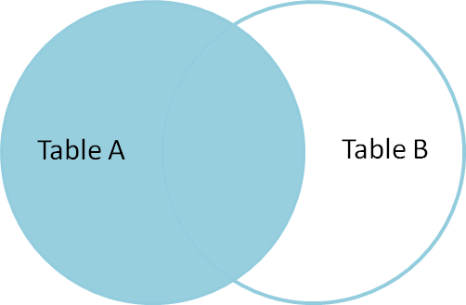

LEFT JOIN Example
In this example, the LEFT JOIN retrieves all rows from the Student table and the matching rows from the StudentCourse table based on the ROLL_NO column.
Query:
SELECT Student.NAME,StudentCourse.COURSE_ID
FROM Student
LEFT JOIN StudentCourse
ON StudentCourse.ROLL_NO = Student.ROLL_NO;
Output
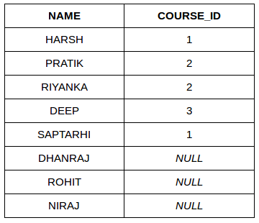

3. SQL RIGHT JOIN
RIGHT JOIN returns all the rows of the table on the right side of the join and matching rows for the table on the left side of the join. It is very similar to LEFT JOIN for the rows for which there is no matching row on the left side, the result-set will contain null. RIGHT JOIN is also known as RIGHT OUTER JOIN.
Syntax
SELECT table1.column1,table1.column2,table2.column1,....
FROM table1
RIGHT JOIN table2
ON table1.matching_column = table2.matching_column;
Key Terms
- table1: First table.
- table2: Second table
- matching_column: Column common to both the tables.
Note: We can also use RIGHT OUTER JOIN instead of RIGHT JOIN, both are the same.
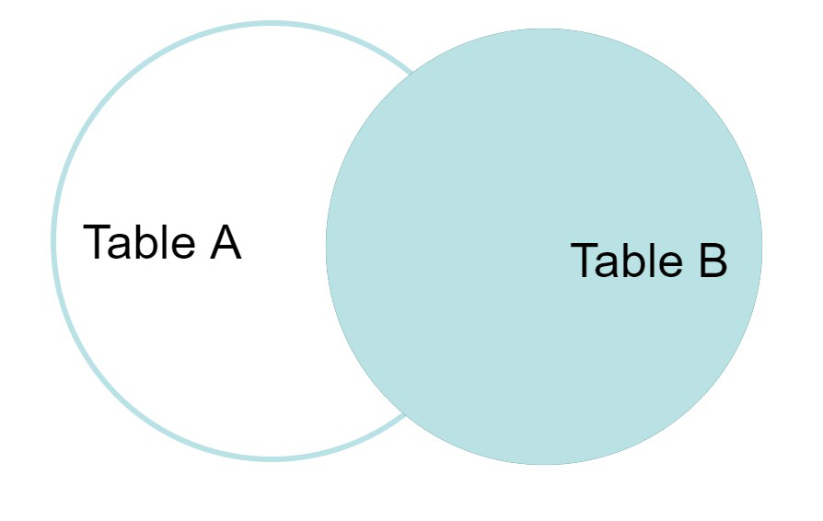

RIGHT JOIN Example
In this example, the RIGHT JOIN retrieves all rows from the StudentCourse table and the matching rows from the Student table based on the ROLL_NO column.
Query:
SELECT Student.NAME,StudentCourse.COURSE_ID
FROM Student
RIGHT JOIN StudentCourse
ON StudentCourse.ROLL_NO = Student.ROLL_NO;
Output
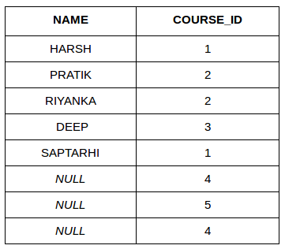

4. SQL FULL JOIN
FULL JOIN creates the result-set by combining results of both LEFT JOIN and RIGHT JOIN. The result-set will contain all the rows from both tables. For the rows for which there is no matching, the result-set will contain NULL values.
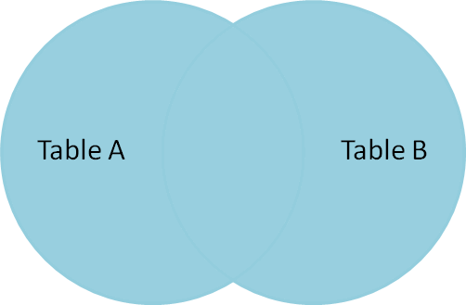
Syntax
SELECT table1.column1,table1.column2,table2.column1,....
FROM table1
FULL JOIN table2
ON table1.matching_column = table2.matching_column;
Key Terms
- table1: First table.
- table2: Second table
- matching_column: Column common to both the tables.

FULL JOIN Example
This example demonstrates the use of a FULL JOIN, which combines the results of both LEFT JOIN and RIGHT JOIN. The query retrieves all rows from the Student and StudentCourse tables. If a record in one table does not have a matching record in the other table, the result set will include that record with NULL values for the missing fields
Query:
SELECT Student.NAME,StudentCourse.COURSE_ID
FROM Student
FULL JOIN StudentCourse
ON StudentCourse.ROLL_NO = Student.ROLL_NO;
Output
NAME | COURSE_ID
HARSH | 1
PRATIK | 2
RIYANKA | 2
DEEP | 3
SAPTARHI | 1
DHANRAJ | NULL
ROHIT | NULL
NIRAJ | NULL
NULL | 4
NULL | 5
NULL | 4

5. SQL Natural Join (?)
Natural join can join tables based on the common columns in the tables being joined. A natural join returns all rows by matching values in common columns having same name and data type of columns and that column should be present in both tables.
- Both table must have at least one common column with same column name and same data type.
- The two table are joined using Cross join.
- DBMS will look for a common column with same name and data type. Tuples having exactly same values in common columns are kept in result.

Natural join Example
Look at the two tables below- Employee and Department
Employee
Emp_id | Emp_name | Dept_id
1 | Ram | 10
2 | Jon | 30
3 | Bob | 50

Department
Dept_id | Dept_name
10 | IT
30 | HR
40 | TIS
Problem: Find all Employees and their respective departments.
Solution Query: (Employee) ? (Department)
Emp_id | Emp_name | Dept_id | Dept_id | Dept_name
1 | Ram | 10 | 10 | IT
2 | Jon | 30 | 30 | HR
Employee data |  |  | Department data

select c.c_id,c_name, o.amount
-> from customer c
-> inner join orders o
-> on c.c_id=o.o_id;
+------+--------+--------+
| c_id | c_name | amount |
+------+--------+--------+
| 1 | robert | 200 |
| 1 | john | 200 |
| 3 | david | 300 |
| 4 | john | 800 |
| 5 | betty | 150 |
+------+--------+--------+
5 rows in set (0.00 sec)

mysql> select c.c_id,c_name, o.amount
-> from customer c
-> left join orders o
-> on c.c_id=o.o_id;
+------+--------+--------+
| c_id | c_name | amount |
+------+--------+--------+
| 1 | john | 200 |
| 1 | robert | 200 |
| 3 | david | 300 |
| 4 | john | 800 |
| 5 | betty | 150 |
+------+--------+--------+
5 rows in set (0.01 sec)

mysql> select c.c_id,c_name, o.amount
-> from customer c
-> right join orders o
-> on c.c_id=o.o_id;
+------+--------+--------+
| c_id | c_name | amount |
+------+--------+--------+
| 1 | robert | 200 |
| 1 | john | 200 |
| NULL | NULL | 500 |
| 3 | david | 300 |
| 4 | john | 800 |
| 5 | betty | 150 |
+------+--------+--------+

